

**NATIONAL ECONOMIC CONSULTATIVE FORUM**

**MONTHLY ECONOMIC BULLETIN**

**JANUARY 2025**

# Executive Summary

This bulletin focuses on economic developments for the month ending 31 January 2025 that include, world economic developments, international commodity prices, Zimbabwe Gross Domestic Product (GDP) growth updates, merchandise trade developments, exchange rate developments, inflation developments, monetary developments and stock market developments.

The global economy is expected to maintain a steady growth rate of 3.3% in 2025 and 2026, despite uneven performance across countries. The US growth forecast has been revised upward, driven by robust labour markets, strong investments, and supportive financial conditions. In contrast, the Euro Area's growth forecast has been revised downward due to weaker momentum in manufacturing and increased uncertainty. China's growth forecast remains stable, as the positive effects of recent fiscal policies offset negative impacts from trade tensions and property market slowdowns. Overall, these revisions balance each other out, resulting in relatively stable global growth forecasts.

Global inflation is projected to decrease to 4.2% in 2025 and 3.5% in 2026, driven by easing demand pressures as labor markets slow and energy prices fall. As a result, inflation is expected to move closer to central banks' target ranges. This downward trend is largely driven by advanced economies, which are approaching their inflation targets faster than emerging markets and developing economies.

Commodity prices saw a mixed trend in January 2025, with significant gains in crude oil, metals, and agricultural products, while natural gas, nickel, and cotton prices declined. The commodity market experienced volatility due to various downside risks, including slowing global economic growth, escalating US-China tensions, and ongoing geopolitical conflicts in the Middle East and Ukraine.

The country’s economic growth remains projected to grow by 6% in 2025. Zimbabwe’s economic outlook is positive, due to an expected recovery in agriculture, and robust growth in industry and services.

As of November 2024, Zimbabwe's merchandise trade surged 21.1% month-on-month to USD1.857 billion in November 2024, driven by growth in both exports and imports, with a 23.2% year-on-year increase. The trade deficit narrowed significantly to USD46.9 million, while exports jumped 29.7% to USD905.2 million, led by gold, tobacco, and platinum group metals (PGMs), with key destinations being the UAE, China, and South Africa. Imports rose 13.9% to USD952.1 million, driven by increased purchases of diesel, maize, petrol, and crude soybean oil, primarily sourced from South Africa, China, and the Bahamas.

In January 2025, the ZWG weakened against major currencies, including the USD, GBP, EUR, and ZAR, due to a stronger USD following the US elections. The ZWG's depreciation was observed on both year-to-date and year-on-year bases. Meanwhile, the parallel market exchange rate declined, but remained higher than the official rate. The official exchange rate slightly increased, narrowing the gap between the two rates and reducing the market premium. The USD also experienced fluctuations, gaining against the GBP but losing against the ZAR on a month-on-month basis, with mixed performance on year-to-date and year-on-year basis.

Zimbabwe's month-on-month inflation rate increased significantly from 3.67% in December 2024 to 10.5% in January 2025, largely due to the devastating drought and new taxes introduced on items like fast food and sports betting. Additionally, weighted inflation surged to 11.60% in January, marking its first double-digit increase since the introduction of the ZWG, driven by accelerating inflation in both ZWG and USD-denominated prices.

As of November 2024, Zimbabwe's broad money stock decreased by 4.97% to ZWG83.23 billion in November 2024, primarily due to exchange rate fluctuations. The money supply composition consisted mainly of foreign deposits (83.87%), followed by local currency deposits (16.01%), and a small portion of local currency in circulation (0.12%). Notably, the foreign currency component of broad money declined by 7.84%, while the local currency component grew by 13.34% on a month-on-month basis.

As of 17 January 2025, local currency deposit rates were revised downward to 3.38-3.54%, while foreign currency deposit rates remained unchanged at 1.35-1.57%. Lending rates on foreign currency decreased for individuals (12.79-17.33%) and corporates (10.62-16.34%), but increased for local currency loans, with individuals facing rates of 41.60-47.12% and corporates facing rates of 40.16-45.9%.

Regarding the stock markets, the Zimbabwe Stock Exchange (ZSE) experienced a downturn in January 2025, with key indicators such as the All Share Index, Top 10 Index, value traded, and market capitalization declining by 10.12%, 10.42%, 73.15%, and 9.61%, respectively. Major stocks like Econet, Delta, NMB, and SEEDCO traded negatively, influenced by exchange rate fluctuations and inflationary pressures. In contrast, the Victoria Falls Stock Exchange (VFEX) showed a bullish trend, with its All Share Index rising 0.81%, value traded increasing 109.95%, and market capitalization growing 31.66%.

**Table of Contents**

Executive Summary i

1.0 World Economic Developments 1

1.1 World Output 1

1.2 Global Inflation Developments 1

2.0 International Commodity Prices 2

3.0 Zimbabwe GDP Growth Update 3

4.0 Merchandise Trade Developments 3

5.0 Exchange Rate Developments 4

5.1 ZWG Exchange Rate Developments 4

5.2 Parallel Market Developments 4

5.3 Cross Rate Developments 5

6.0 Inflation Developments 5

7.0 Monetary Developments 7

7.1 Money Supply 7

7.2 Interest Rates 8

8.0 Stock Market Developments 8

8.1 Zimbabwe Stock Exchange (ZSE) 8

8.2 Victoria Falls Stock Exchange (VFEX) 9

9.0 Recommendations 10

10 References 11

**List of Tables**

Table 1: Global Economic Growth Developments 1

Table 2: Commodity Price Movements – Month Ending 31 January 2025 3

Table 3: ZWG Exchange Rate Movements-Month Ending 31 January 2025 4

Table 4: USD Exchange Rate Movements–Month Ended 31 January 2025 5

Table 5: Monthly Inflation for January 2025 7

Table 6: Interest Rates as of 17 January 2025 8

Table 7: Zimbabwe Stock Exchange Movements 9

Table 8: Victoria Falls Stock Exchange Movements 9

**List of Figures**

Figure 1: Global Inflation 2

Figure 2: Merchandise Trade Developments 3

Figure 3: Parallel Market Developments – January 2025 4

Figure 4: Month-on-Month ZWG Inflation Outturn 5

Figure 5: Month-on-Month Weighted Inflation Outturn 6

Figure 6: Broad Money (M3) Supply 7

# 1.0 World Economic Developments

## **1.1 World Output**

1.1.1 The global economy is projected to be steady at 3.3% in 2025 and 2026, respectively as shown in Table 1, albeit lacklustre economic performance with varied degree of grip across countries (IMF, 2025). In the United States, growth was revised 0.5% higher than the October forecast, reflecting strong wealth effects, less restrictive monetary stance, supportive financial conditions, robust labour markets, accelerating investments and carryover from 2024. A downward revision in the Euro-Area growth is due to weaker-than-expected momentum at the end of 2024, especially in manufacturing, heightened political and policy uncertainty. The revision in China reflects carryover from 2024 and the fiscal package announced in November largely offsetting the negative effects on investment from heightened trade policy uncertainty and property market drag. Overall, these revisions balance each other out, resulting in relatively stable global growth forecasts.

Table 1: Global Economic Growth Developments

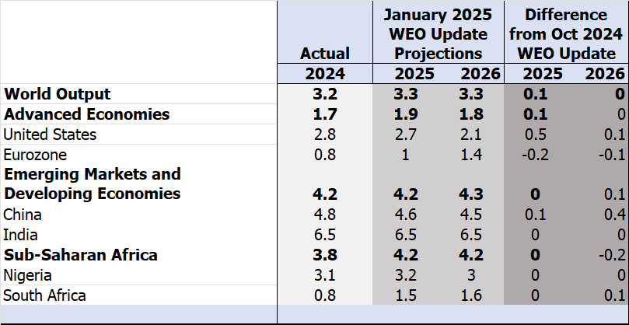

*Source: IMF, WEO October 2024 and January 2025 Updates*

## **1.2 Global Inflation Developments**

1.2.1 According to IMF (2025), global headline inflation is expected to decline to 4.2% in 2025 and to 3.5% in 2026 (see Figure 1). As labor markets moderate, demand pressures are likely to ease, while falling energy prices will further contribute to a decline in inflation, moving it closer to the central bank's target range. The World Economic Forum (2025) highlighted that global inflation continues to ease, primarily driven by the advanced economies, which have been converging to their inflation targets more rapidly than emerging-market and developing economies.

Figure 1: Global Inflation

*Source: IFM, WEO January 2025 update*

# 2.0 International Commodity Prices

2.1 In January 2025, crude oil, aluminum, copper, gold, soyabeans, corn and wheat prices surged by 1.38%, 1.72%, 6.92%, 6.58%, 4.38%, 5.13% and 1.45% respectively, yes natural gas, nickel and cotton prices abated, see Table 2. According to The Business Insider (2025), January has been a roller coaster for commodities due to downside risks, such as slowing global economic growth, the deteriorating US-China relationship and geopolitical conflicts in the Middle East and Ukraine.

2.2 On a year-to-date basis, aluminum, copper, nickel, gold, soyabeans, corn and wheat prices increased, while prices of crude oil, natural gas and cotton declined, as shown Table 2.

2.3 On a year-on-year basis, prices for natural gas, aluminum, copper, gold, and corn increased, whereas prices for other commodities declined

Table 2: Commodity Price Movements – Month Ending 31 January 2025

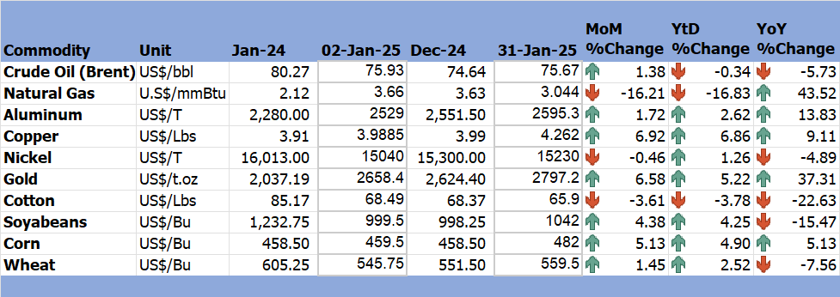

*Source: Trading Economics (2025)*

# 3.0 Zimbabwe GDP Growth Update

3.1 The country’s economic growth remains projected to grow by 6% in 2025. According to the World Bank (2024), Zimbabwe’s economic outlook is positive, due to an expected recovery in agriculture, and robust growth in industry and services.

# 4.0 Merchandise Trade Developments

4.1 Zimbabwe National Statistics Agency (ZimStat) had not published the merchandise trade data for January 2024 by the time of compiling this report, thus the analysis is based on November 2024 data.

4.2 Zimbabwe's total merchandise trade surged 21.1% month-on-month to USD1.857 billion in November 2024, driven by rises in both exports and imports. Compared to the same period in 2023, trade volumes jumped 23.2% from USD1.507 billion (RBZ November 2024 Monthly Review).

4.1 Zimbabwe's trade deficit narrowed significantly to USD46.9 million in November 2024, down from USD137.7 million in October 2024 and USD144.5 million in November 2023 (see Figure 3). Merchandise exports jumped 29.7% to USD905.2 million in November 2024, driven by increased export earnings from gold, tobacco, and platinum group metals (PGMs), with key destinations being the UAE, China, and South Africa, which collectively accounted for 80.3% of total exports. Import bill rose 13.9% to USD952.1 million in November 2024, driven by increased purchases of diesel, maize, petrol, and crude soybean oil, primarily sourced from South Africa, China, and the Bahamas, which together accounted for 61.8% of total imports.

Figure 2: Merchandise Trade Developments

*Source: RBZ (2024)*

# 5.0 Exchange Rate Developments

## **5.1 ZWG Exchange Rate Developments**

5.1.1 In January 2025, the ZWG lost value against the USD, GBP, EUR and ZAR by 2.2%, 1.14%, 2% and 3.55% respectively. According to NewsDay (31 January 2025), the ZWG depreciated on account of stronger USD (post-election). The ZWG lost value against all major currencies on a year-to-date and year-on-year basis as shown in Table 2.

Table 3: ZWG Exchange Rate Movements-Month Ending 31 January 2025

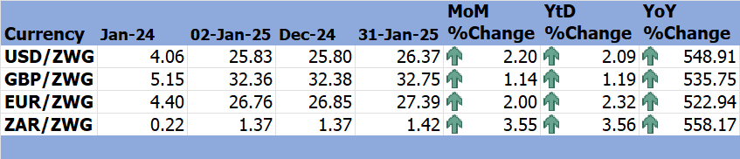

*Source: RBZ (2024 & 2025)*

## **5.2 Parallel Market Developments**

5.2.1 Parallel market exchange rate gradually declined in January 2025, however, it remained higher than official exchange rate. The official exchange rate slightly increased, bridging the gap between the two exchange rates hence decreasing the market premium, see Figure 4. The decline in parallel exchange rate reflects the tight monetary stance by the government.

Figure 3: Parallel Market Developments – January 2025

*Source: RBZ and Harare Streets (2025)*

## **5.3 Cross Rate Developments**

5.3.1 On a month-on-month, the USD gained by 1.04% and 0.19% against the GBP and EUR respectively, while retreated by 1.3% against the ZAR, see Table 3. The USD gained against the GBP on YtD basis while lost against the EUR and ZAR. On a YoY basis, the USD also gained against the GBP and EUR by 2.05% and 4.17% respectively while lost by 1.46% against the ZAR.

Table 4: USD Exchange Rate Movements–Month Ended 31 January 2025

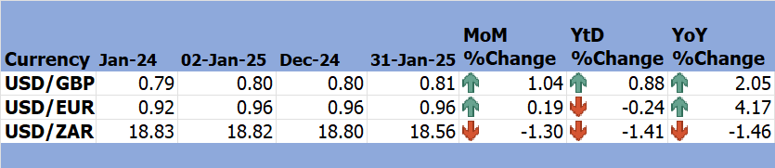

*Source: RBZ (2024 & 2025)*

5.3.2 The appreciation of USD against the ZAR encourages the country’s exports to South Africa, however, USD depreciation instigated imported inflation since the economy highly depends on USD.

# 6.0 Inflation Developments

6.1 Month-on-month ZWG inflation hiked from 3.67% in December 2024 to 10.5% in January 2025, see Figure 5. According to Trading Economics (2025), the spike was primarily attributed to the prolonged drought and the recent introduction of additional taxes, targeting areas such as sports betting and popular fast foods like French fries, burgers, and pizza, in a bid to boost government revenue amid the ongoing fiscal challenges facing the economy.

Figure 4: Month-on-Month ZWG Inflation Outturn

*Source: ZimStat (2025)*

6.2 M-o-M weighted inflation also rose, reaching a two-digit level since the introduction of the ZWG, from 1.11% in December to 11.60% in January 2025 due to acceleration of both ZWG and USD inflation. (see Figure 6).

Figure 5: Month-on-Month Weighted Inflation Outturn

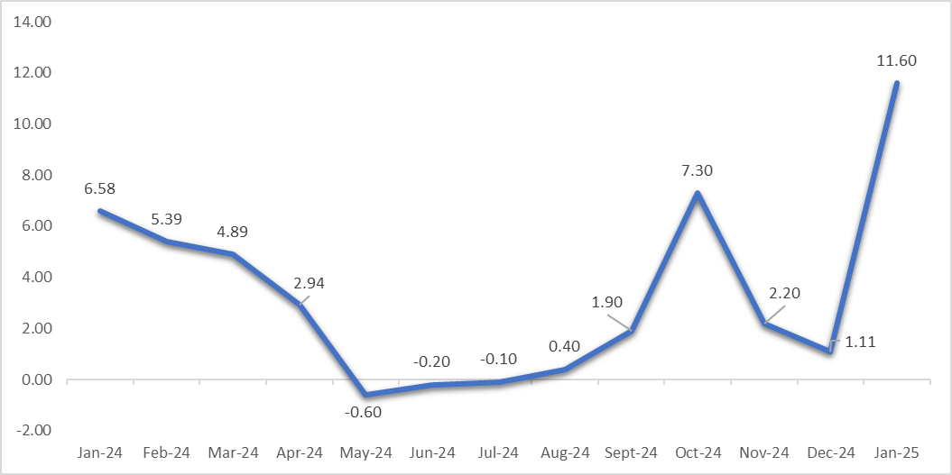

*Source: ZimStat (2025)*

6.3 Food and non-alcoholic drinks, as well as housing, water, electricity, gas, and other fuels, continue to be the largest drivers of inflation in January 2025 (see Table 4).

Table 5: Monthly Inflation for January 2025

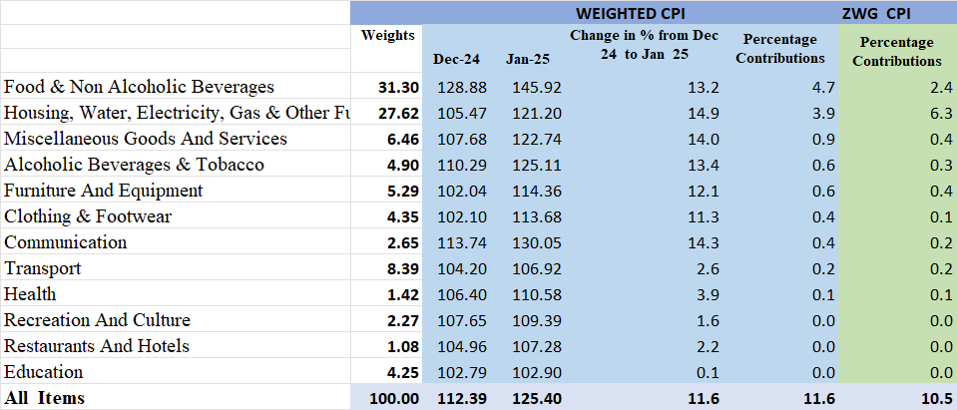

*Source: ZimStat (2025)*

# Monetary Developments

## **7.1 Money Supply**

7.1.1 By the time of compiling this report, January 2025 money supply statistics had not been published thus analysis is based on November 2024 data.

7.1.2 Broad money stock stood at ZWG83.23 million in November 2024, a 4.97% decline from ZWG87.58 billion recorded in October 2024, see Figure 7. According to RBZ (2024), money supply stock decline reflected valuation changes related to exchange rate appreciation. Money supply stock comprised of foreign deposits (83.87%), local currency deposits (16.01%) and local currency in circulation (0.12%). The foreign currency component of broad money contracted by 7.84% albeit the local currency component expanded by 13.34% on a month-on-month.

Figure 6: Broad Money (M3) Supply

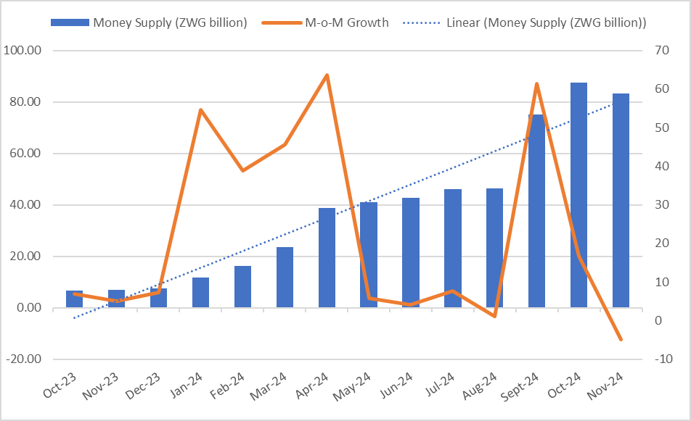

*Source: RBZ (2024)*

## **7.2 Interest Rates**

7.1.1 As of 17 January 2025, the average commercial bank deposit rate for savings on local currency was reviewed downward to 3.38% minimum and 3.54% maximum, while it was maintained at 1.35% minimum and 1.57% maximum on the foreign currency. The weighted lending rate on the foreign currency for individuals was reduced to a minimum 12.79% and maximum of 17.33%, for individuals, while the minimum was lowered to 10.62% and maximum raised to 16.34% for corporates. Weighted lending rates on local currency were raised upwards to a minimum rate of 41.60% and to a maximum rate of 47.12% for individuals and to 40.16% minimum and 45.9% maximum for corporates (see Table 5).

Table 6: Interest Rates as of 17 January 2025

|  |  |  |  |  |  |
| --- | --- | --- | --- | --- | --- |
| **Classification** | | **Minimum (%)** | | **Maximum (%)** | |
|  | | **13/12/24** | **17/01/25** | **13/12/24** | **17/01/25** |
| Average Commercial Bank Deposit Rates | Local Currency | 3.75 | 3.38 | 3.88 | 3.54 |
| Foreign Currency | 1.35 | 1.35 | 1.57 | 1.57 |
| Commercial Banks Weighted Lending Rates (Forex) | Individuals | 13.03 | 12.79 | 17.42 | 17.33 |
| Corporates | 10.67 | 10.62 | 16.24 | 16.34 |
| Commercial Banks Weighted Lending Rates (ZWG) | Individuals | 41.43 | 41.60 | 46.89 | 47.12 |
| Corporates | 39.98 | 40.16 | 45.48 | 45.9 |

*Source: RBZ (2025)*

7.1.2 During the period under review, deposit rates for local currency were adjusted downward diminishing the incentive to save while on the other hand lending rates were generally increased resulting in rise of cost of borrowing hindering investment the economy.

# 8.0 Stock Market Developments

## **8.1 Zimbabwe Stock Exchange (ZSE)**

8.1.1 During the period under review, the ZSE continued to record bearish sentiments. All share index, top 10 index, value traded, and market capitalization fell by 10.12%, 10.42%, 73.15% and 9.61%, respectively, see table 6. According to ZSE (2025), the performance of the ZSE eased with Econet, Delta, NMB and SEEDCO trading in the negative. Bulls and Bears (2025) argued that exchange rate movement has had a significant bearing on inflationary pressures in the economy which has an impact on the movement of equity prices.

8.1.2 On year-to-date and year-on-year, all selected indices dwindled except the top 10 index (98.39%) and market capitalisation (253.32%) on y-o-y basis.

Table 7: Zimbabwe Stock Exchange Movements

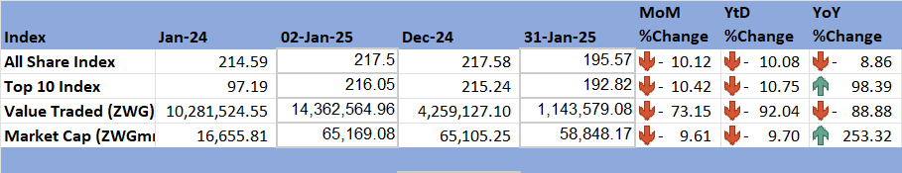

*Source: ZSE (2025)*

## **8.2 Victoria Falls Stock Exchange (VFEX)**

8.2.1 The VFEX continued to record a bullish trend in January 2025, with all share index gaining 0.81%, value traded hiked by 109.95% and market capitalization grew by 31.66%.

8.2.2 All other indices grew on YtD and YoY basis, except all share index falling by 1.48% and value traded also falling by 35.21%.

Table 8: Victoria Falls Stock Exchange Movements

*Source: VFEX (2025)*

# 9.0 Recommendations

9.1 The following recommendations are being proposed:

**9.1.1 Monetary Policy Adjustment:** Despite the Reserve Bank’s tight monetary stance, the ZWG continued to depreciate against major currencies and inflation grew significantly. The Reserve Bank must promote usage of ZWG than the USD to improve the effectiveness of the Monetary Policy on stabilizing the macroeconomic environment in Zimbabwe. The Bank may adjust interest rates to strike a balance between borrowing and controlling inflation, stabilizing the exchange rate to eliminate the discrepancies in the foreign exchange market.

* + 1. **Fiscal Austerity:** The Government should uphold fiscal responsibility by implementing rigorous spending controls, aiming to reduce the budget deficit, curb inflation, and stabilize the exchange rate, ultimately driving sustainable economic growth.
    2. **Boost Investment and Trade:** The government must implement policies foreign direct investment particularly in key sectors like agriculture, mining and manufacturing. Export destination diversification is crucial to reduce dependency on traditional markets like South Africa and China. The economy must leverage on regional trade agreements, such as the African Continental Free Trade Area (AfCFTA), to increase trade with other countries. Wide free trade present immense opportunities for export diversification, access to raw materials and technology.
    3. **Enhancing Agriculture and Mining Sector:** Given an increase in prices of agricultural commodities and minerals like gold and copper (reflecting potential earnings) on the international market. The Government must implement policies to support agricultural development, including irrigation, mechanisation and agricultural financing and invest in mineral production and its value chain to improve the country’s export earnings.

**9.1.5 Enhance Stock Market Liquidity:** To revitalize Zimbabwe's capital markets, particularly the struggling Zimbabwe Stock Exchange (ZSE), it's essential to boost liquidity and attract investors. Both ZSE and VFEX should focus on implementing measures such as investor education programs, tax incentives for institutional investors, and leveraging technology to enhance market efficiency and competitiveness.

# 10 References

IMF. (2024). *World Economic Outlook, October 2024; Global prospects and Policies: Chapter 1.* International Monetary Fund.

International Monetary Fund. (2025). *World Economic Outlook, January 2025 Update.* IMF.

RBZ. (2025). *Exchange Rates*. Retrieved from Reserve Bank of Zimbabwe: https://www.rbz.co.zw/index.php/research/markets/exchange-rates

Reserve Bank of Zimbabwe. (2024). *Monthly Economic Review: November 2024.* RBZ.

Reserve Bank of Zimbabwe. (2025). *Weekely Economic Highlights, 17 January 2024, Vol 27 No 3.* Reserve Bank of Zimbabwe.

Trading Economics. (2025). *Commodities*. Retrieved from Trading Economics: https://tradingeconomics.com/commodity/crude-oil

VFEX. (2025). *Main Dashboard*. Retrieved from Victoria Falls Stock Exchange: https://www.vfex.exchange/

ZimStat. (2025). *Inflation Rates*. Retrieved from Zimbabwe Statistics Agency: https://www.zimstat.co.zw/

ZSE. (2025). *Main Dashboard*. Retrieved from Zimbabwe Stock Exchange: https://www.zse.co.zw/